The Republican Club of Southwest Florida
August 01, 2024 Meeting Minutes
Lions Club of Bonita Springs, FL

Meeting called to order: President Bill Ribble called the meeting to order at 6 pm.
Invocation: Secretary, Larry Fiesel
Pledge of Allegiance: Vice-President, Fred Forbes
Officers Present: President Bill Ribble, Vice-President Fred Forbes, Secretary Larry Fiesel, Treasurer Jim Sido, Director Joanne Ribble, Carolyn Forbes.
Recognition of Elected Officials: Lee County Commissioner, Ray Sandelli, Bonita Springs Deputy Mayor Fred Forbes, Estero Vice Mayor Joanne Ribble, Estero Council Members Rafael Lopez, Larry Fiesel
Recognition of Sponsor: Engel & Volkers- Jim Hollars.
Approval of May 02 and June 06, 2024 Meeting Minutes: Motion to approve by Bob Pritt, Seconded by Amy Quaremba. Motion was unanimously approved.
Treasurer's Report: May 2024

Income:
07-03-2024 Wire Jim Hollars 3,000.00
07-23-2024 2063 Tom Bryan & Linda Howard 25.00
07-23-2024 James Mullen 50.00

Total 3,075.00

Disbursements:
07-10-2024 Debit Recurring Wix.com 12.00
07-19-2024 Debit Miklas Social 385.00

Total 397.00

Summary:
Beginning Balance 395.53
Deposits 3,075.00
Disbursements 397.00
Ending Balance 3,073.53

Business Savings Account 727.49
Approval of May 2024 Treasurer's Report: Motion to approve by Fran Mainella, Seconded by Nancy Sido. Motion was unanimously approved.

Order of Business & Introduction of Speaker: Lee County Commissioner, Mike Greenwell
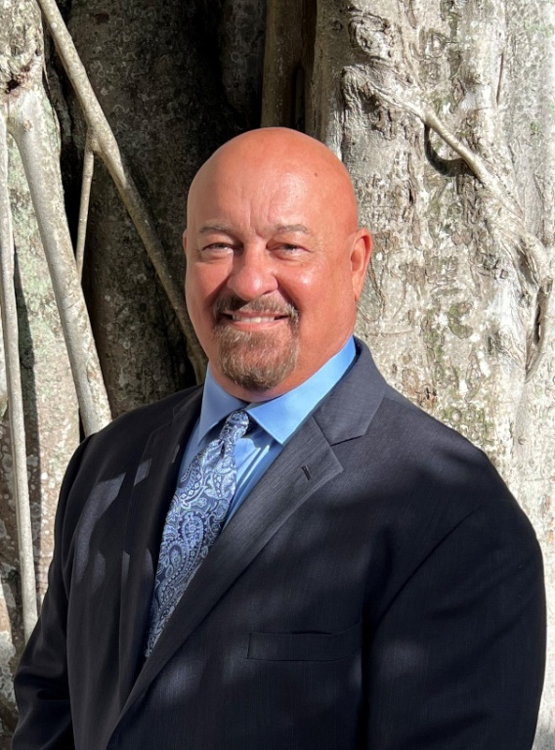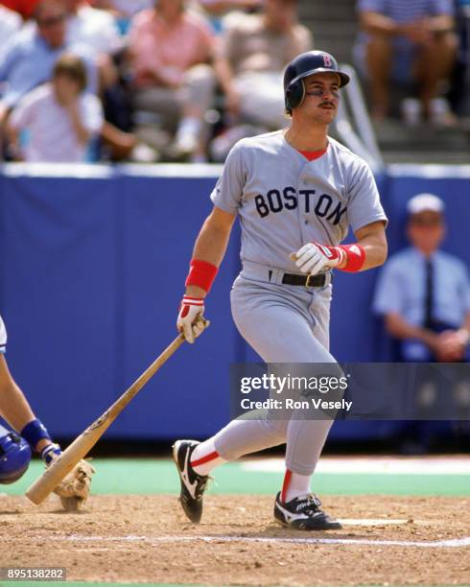

Michael Lewis Greenwell is an American former left fielder in Major League Baseball who played his entire MLB career with the Boston Red Sox. He played seven games for the Hanshin Tigers in Japan, before retiring. Greenwell was nicknamed "The Gator", he loved to hunt alligators.
Mike Greenwell was drafted by the Boston Red Sox in the 3rd round of the 1982 MLB June Amateur Draft from North Fort Myers High School.
Commissioner Mike Greenwell is proud to serve the citizens of Lee County. After a 12-year professional career with the Boston Red Sox, he returned to Lee County to raise his family and become a businessman.
Mike was appointed to the Lee Board of County Commissioners on July 22, 2022, by Governor Ron DeSantis. He is the liaison to the Southwest Florida Regional Planning Council and the Coastal & Heartland National Estuary Partnership. As a commissioner, he also serves on boards for the Lee County Metropolitan Planning Organization and Lee County Port Authority.
He is passionate about protecting our water quality for generations to come. Other priorities include improving the county's transportation network, preparing for growth and maintaining the county's infrastructure, focusing on economic growth and keeping taxes low for Lee County families and businesses.
Mike and his wife, Tracy, are Alva residents and active in the community. He is the past president and vice president of the community board in North Olga.
- Raised in Lee County since being four-years old, moved here from Louisville KY
- 1982 was going to the University of Miami, was drafted by Boston Red Sox out of high school
- Was 21-years old entering the Major Leagues
- Finished second in 1988 AL MVP
- First three hits in the Major League were home runs, still a Major League record
- Lifetime 300 hitter
- Red Sox Hall of Fame, played his entire career for the Red Sox
- 63 years only four Red Sox played left field: Ted Williams, Carl Yastrzemski, Jim Rice and Mike Greenwell
- Bought five-acres of farm land for $15K on north side of Caloosahatchee River
- Lee County Civic Center was allowed to run down so much it is now condemned. The Board of County Commissioners is going to restore the center and bring something special back to Lee County
- 70-80 school tours each year at his farm which has a restaurant and petting zoo
New Business: There was no new business.
Introduction of Candidates:
David Mulicka, Lee County Commissioner

Andrew Sund: Republican State Committeeman
Carolyn Forbes: Bonita City Council
Stephanie Kissinger: Bonita Springs Fire Commissioner, Seat 2
Bill Ribble, Lee County School Board District 3
Derek Felder: Lehigh Acres Fire Board

Next Meeting September 05, 2024: State Attorney, Amira Fox
Meeting Adjourned 7:05 PM.

