Republican Club of Southwest Florida

April 04, 2024 Meeting Minutes

Lions Club of Bonita Springs, FL

Meeting Called to Order: President Bill Ribble called the meeting to order at 6:00

Invocation: Secretary Larry Fiesel

Pledge of Allegiance: Secretary Larry Fiesel

Officers Present: President Bill Ribble, Vice-President Fred Forbes, Secretary Larry Fiesel, Treasurer Jim Sido, Director Joanne Ribble

Recognition of Elected Officials: Lee County Commissioner Ray Sandelli, Lee Health Board Member David Klein, Bonita Springs Deputy Mayor Fred Forbes, Bonita Springs Council Member Nigel Fullick, Estero Vice Mayor Joanne Ribble, Estero Council Members Larry Fiesel, George Zalucki, Rafael Lopez

Recognition of Sponsor: Engel & Volkers - Jim and Ellen Hollars
Approval of March 07, 2024 Meeting Minutes: Motion to approve by George Zalucki, Seconded by Fran Mainella. Motion was unanimously approved.

Treasurer's Report: March, 2024

Income:
March 08, 2024 Square Membership - Brandon Miller ($100) 96.80
March 11, 2024 Square Membership - Amira Fox 23.97
March 12, 2024 Dues - Suzanne Hobbs, Tara Jenner, Roxanne Buckles, 300.00
Robert Paul, Mary Ann Rain ($100)
March 27, 2024 Square Due Membership - Cliff Brand 96.80

Total 517.77

Disbursements:
March 07, 2024 Debit Recurring Wix.com 12.00
March 11, 2024 #149 Lions Club of Bonita Springs 175.00
March 20, 2024 Debit Miklas Social 385.00

Total 572.00

Summary:
Beginning Balance 1,429.19
Income 517.77
Disbursements 572.00
Ending Balance 1,374.76

Business Savings 467.49
Approval of Treasurer's Report: Motion to approve by Fran Mainella, Seconded by Nancy Sido. Motion was unanimously approved.

Order of Business & Introduction of Guest Speaker: Lee County Board of Commissioner Cecil Pendergrass.

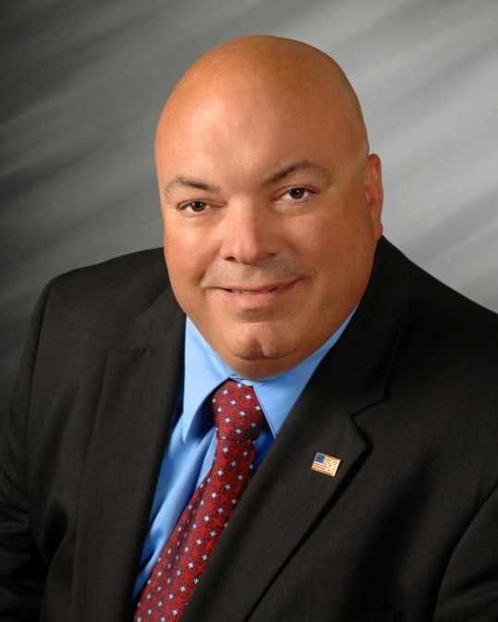

Commissioner Cecil Pendergrass, a lifelong resident of Lee County and son of WWII veteran, has always been an advocate for our community. Cecil faithfully served the people of Lee County as a Fort Myers Police Officer for 25 years. Following retirement from law enforcement, Cecil worked as Vice President of Private Asset Management Group, LLC.
In November 2012, Cecil ran for public office and was elected to the Lee Board of County Commissioners – District 2. In a vote of confidence from his colleagues, he was unanimously sworn in as Chairman of the Board at his first meeting.
In 2014, he was awarded The News-Press’ 2013 Public Official of the Year and received the Advanced Certified County Commissioner (ACCC) designation through the Florida Associations of Counties (FAC). In November 2014, Cecil was reelected to serve another four years. In his
role as county commissioner, serves on multiple boards and advisories of which a few are-Lee County Metropolitan Planning Organization (MPO), Transportation Expressway Authority Management of Florida (TEAMFL), Tourist Development Council, and Lee Health Trauma Advisory Committee.
Cecil also serves on the Board of Port Commissioners overseeing all Lee County’s airports. Cecil appreciates the importance of preserving and protecting the Florida ecosystem while promoting responsible growth to stimulate the local economy. He is committed to protecting our community by safeguarding our area’s natural resources by actively advocating for water quality projects and the Conservation 20/20 Lands program, improving our roadways for safe and timely travel, controlling spending, creating a business-friendly environment to stimulate job growth, and maintaining a safe/secure public safety program.
On November 8, 2022, with overwhelming support from the voters, he was reelected to serve another four years.

Cecil addressed wanted to talk about the traffic in Lee County and addressed theTransportation Priorities by the Lee Board of County Commissioners.

Recently completed projects:
- Homestead Road
- Burnt Store Road
- Corkscrew Road - Phase I
- Estero Boulevard
- Gateway/Commerce Lakes
- Alico Road - Phase I
Currently under construction:
- Gateway/Griffin Roundabout, $4,718,162, approved January 17, 2023
- Three Oaks Parkway, Phase I, $158,012,974, approved May 16, 2023
- Big Carlos Pass Bridge Replacement, $104,178,433, approved February 06, 2024
- Little Pine Island Bridge Replacement, $2,449,458, completion Spring 2025
- Littleton Road 3-Laning, $22,722,202, approved October 17, 2023
- Corkscrew Road 4-Lane, BellaTerra to Alico, $60,137,454, approved December 05, 2023
Projects in design:
- Alico Road extension
- Cape Coral Bridge
- Three Oaks Parkway, Phase II
- Burnt Store North

Lee County Board of County Commissioners has approved over $4B for road construction projects over the next four years.

Recognition: Florida League of Cities 'Home Rule Hero Award' was presented to Joanne Ribble and Fred Forbes in recognition of their contributions to this year's State Legislation agenda. The Florida League of Cities is recognizing nearly 160 municipal officials with Home Rule Hero Awards for their work during the 2024 legislative session.
Home Rule Hero Award recipients are local government officials, both elected and nonelected, who consistently responded to the League’s request to reach out to members of the legislature and help give a local perspective on an issue. They worked tirelessly throughout the legislative session to promote local voices making local choices, protect the Home Rule powers of Florida’s municipalities and advance the League’s legislative agenda.

New Business: There was no new business

Introduction of candidates:

Josh Molandes, Candidate Lee County School Board, District 7

Andrew Sund, Candidate Republican State Committeeman

Ruth Condit, Candidate Bonita Springs Mayor

Next Meeting: May 02, 2024, Chauncey Goss, Board Chairman South Florida Water Management District

Meeting Adjournment: Motion to adjourn by Brandon Miller, meeting was adjourned at 7:04 PM..

