The Republican Club of Southwest Florida
December 05, 2024 Meeting Minutes
Lions Club of Bonita Springs, FL

Meeting called to order: Vice-President, Fred Forbes called the meeting to order at 6 pm.
Invocation: Secretary, Larry Fiesel
Pledge of Allegiance: Vice-President, Fred Forbes
Officers Present: Vice-President Fred Forbes, Secretary Larry Fiesel, Treasurer Jim Sido, Directors Joanne Ribble, Carolyn Forbes
Recognition of Elected Officials: Estero Vice Mayor Joanne Ribble, Estero Council Members , Larry Fiesel, George Zalucki,
Recognition of Sponsor: Engel & Volkers- Jim Hollars.
Approval of November 04, 2024 Meeting Minutes: Motion to approve by Bob Pritt, Seconded by Nathan Fred Shaw . Motion was unanimously approved.
Treasurer's Report: November 2024

Income:
11-08-2024 Square Membership Fran Mainella, James Ward 193.65
11-18-2024 Membership Derek Felder 25.00
10-18-2024 Trans TRF from savings and Jim Sido 684.60

Total 903.25

Disbursements:
11-18-2024 Trans TRF from savings and Jim Sido 684.60
11-18-2024 Debit Lifestyle239 - Web Services 192.00
11-12-2024 Ck 157 Lions Club of Bonita Springs 175.00
11-12-2024 Ck 156 Lions Club of Bonita Springs

Total 1,226.60

September Summary:
Beginning Balance 1,965.80
Deposits 903.25
Disbursements 1,226.60
Ending Balance 1,642.45
Business Savings Account 42.92
Approval of September, 2024 Treasurer's Report: Motion to approve by Jim Sido, Seconded by Nancy Sido. Motion was unanimously approved.

Order of Business & Introduction of Guest Speaker: Brandon Miller

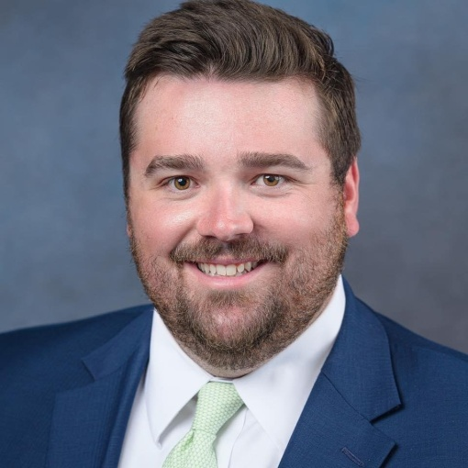
What do the first campaigns of Congressman Byron Donalds, Senator Jonathon Martin and governor Ron DeSantis all have in common?

They all first ran for office in their early 30s as Young Republicans.

Brandon is currently Century Link's Local Public Affairs & Permitting Manager where he oversees the expansion of their fiber optic internet installation in Southwest and North FL. He also assists in maintaining close relationships with elected officials at the local, state, and federal level where he successfully lobbied for a $15M company investment on Sanibel Island following Hurricane Ian to upgrade their telecommunications facilities.

Prior to working in Telecomm, Brandon served five years in the Florida House of Representatives as a senior legislative aide. He worked on a wide range of issues including health quality and access, early childhood education, government overreach, and protecting our natural resources. His last 18 months in the FL House was under the supervision of former Representative Spencer Roach.

During this time, Brandon was the President and Vice President of the SWFL Young Republicans. He and the other Board Members focused on building a strong community of like minded conservatives through events such as guest speakers, Dave & Buster's game nights, and an annual ugly sweater Christmas Party. While he is no longer on the Board, he still maintains active membership working to build up the bench of young Conservative leaders.
In addition, Brandon currently serves on the Board of the Greater Fort Myers Chamber of Commerce where he is the Chair of the Government Affairs Committee. He also serves on the Lee County Parks & Recreation Citizen Advisory Board.

Brandon lives in Estero with his amazing dog Sadie. If he’s not at home, you can find Brandon watching his Florida State Seminoles lose, down by the beach, or missing fairways on the golf course.
- Brandon was born and raised in Tallahassee, FL
- Moved to Ava Maria to attend Ava Maria University for his education
- After graduation returned to Tallahassee to work in the State Capital
- 18-months ago returned to Ft Myers to work for Spencer Roach
- Brandon got involved in Young Republicans because the cost of inaction is too great
- Florida Young Republicans has 20 individual, regional and county clubs that made over one million voter contacts during the recent presidential election
- 2008 was a Social Media Election
- 2024 was a Podcast Election, Donald Trump won 80% of the 18-34 year old voters via Podcast, i.e. Joe Rogan Podcast
- Many Lee County Young Republicans are in local leadership positions: Kevin Karnes, Andrew Sund, Krissy Houlihan for example
- The local Young Republican Club meets the last Thursday of each month in rotating locations

New Business: Mercedes Price Harry, newly elected Chair, spoke about the Lee County Republican Executive Committee, how the committee functions, the challenges ahead and her plans as Chair for the coming year. She introduced Steve Roth, newly elected Treasurer.
Next Meeting: There will be no meeting in January, 2025
Meeting Adjourned 6:48 PM.

